

**CS110: Fundamentals of Computer Programming**

**NAME:** Sara Fawad

**CMS ID:** 509615

**CLASS:** BSDS-02-A

**ASSIGNMENT:** 1

**TASK 1:**

Write a program to get a natural number N from the user and generate N first Fibonacci series numbers.

**INPUT:**

#include <iostream>

using namespace std;

int main()

{

int n, i, term1 = 0, term2 = 1, nextterm;

cout << "Enter the number of terms:" << endl;

cin >> n;

cout << "Fibonacci series:" << endl;

cout << term2 << ",";

for (int i = 0;i <= 20;i++) {

nextterm = term1 + term2;

cout << nextterm << ",";

term1 = term2;

term2 = nextterm;

}

return 0;

}

**OUTPUT:**

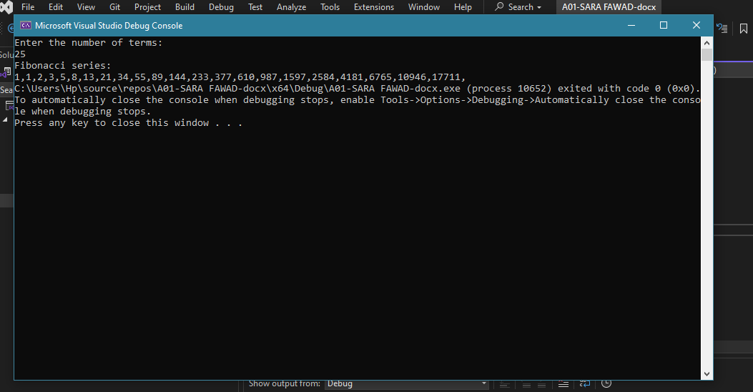

**Task 2**:

Write a program that gets two natural numbers from the user and calculates the Least Common Multiple (LCM) of those two numbers.

**Input:**

#include <iostream>

using namespace std;

int main()

{

int a, b, i;

cout << "Enter any two numbers:" << endl;

cin >> a >> b;

for (i = 1;i > 0;i++) {

if (i % a== 0 && i % b == 0)

{

cout << "LCM of these two numbers is:" << endl;

cout << i;

break;

}

}

return 0;

}

**Output:**

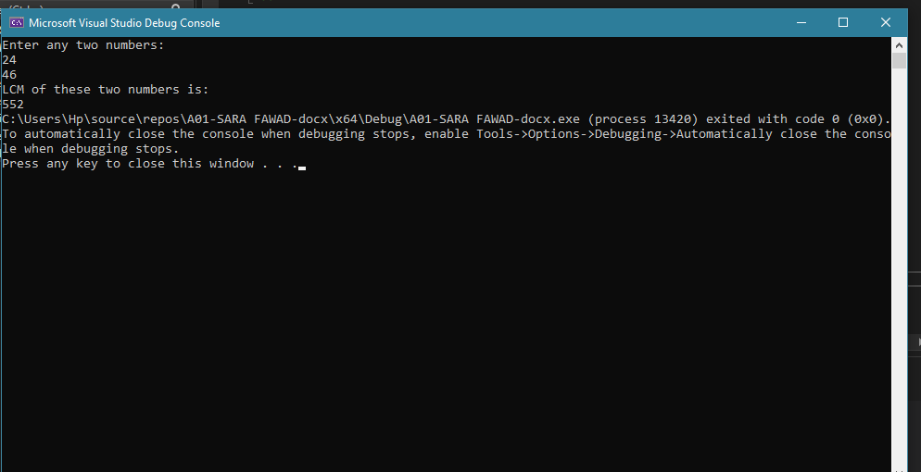

**Task 3:**

Write a program that gets the number of rows from the user and generates the following patterns using for loops.

**Input:**

#include <iostream>

using namespace std;

int main()

{

int rows;

cout << "Enter the number rows:" << endl;

cin >> rows;

for (int a = 0;a <= rows;a++)

{

for (int b = 0;b <a;b++) {

cout <<" ";

}

for (int c=0;c<(rows-a)*2-1;c++) {

cout << "*";

}

cout << endl;

}

return 0;

}

**Output:**

**For 7 number of rows**

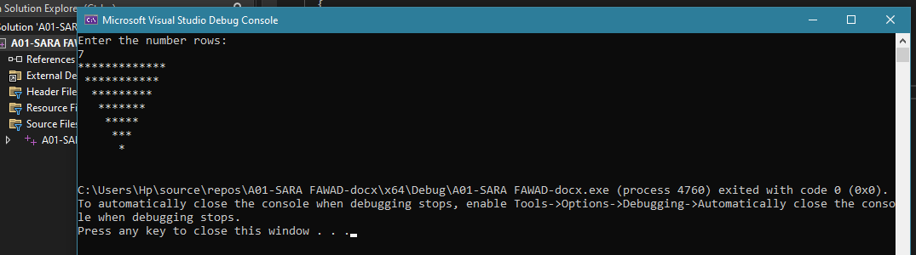

**For 4 number of rows**

